Michael Fang
Laboratory 4

Report on steps:
1) Setting up Redshift Cluster.

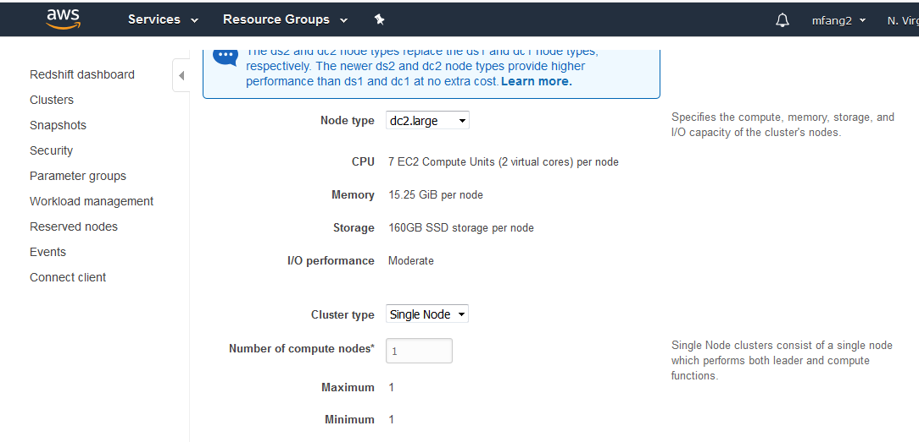
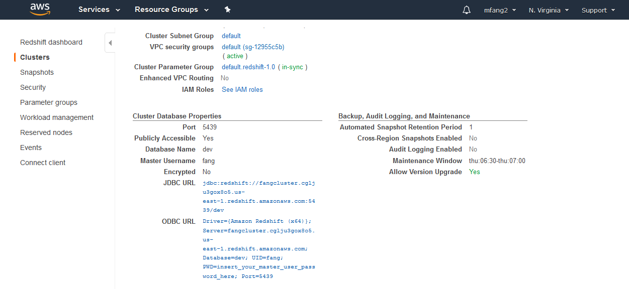

2) Setting up JackDB
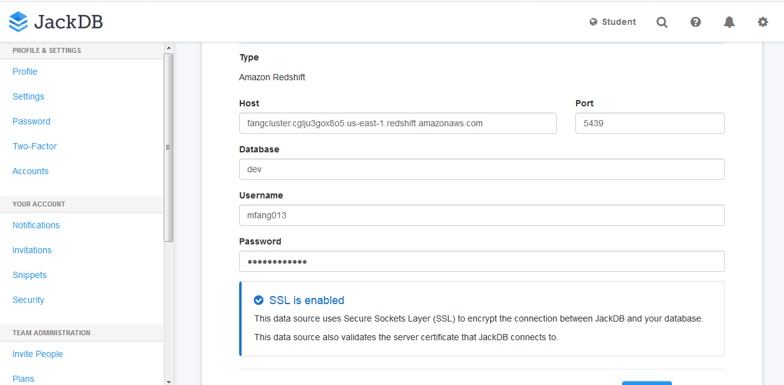

3) modify security group to allow for incoming TCP:
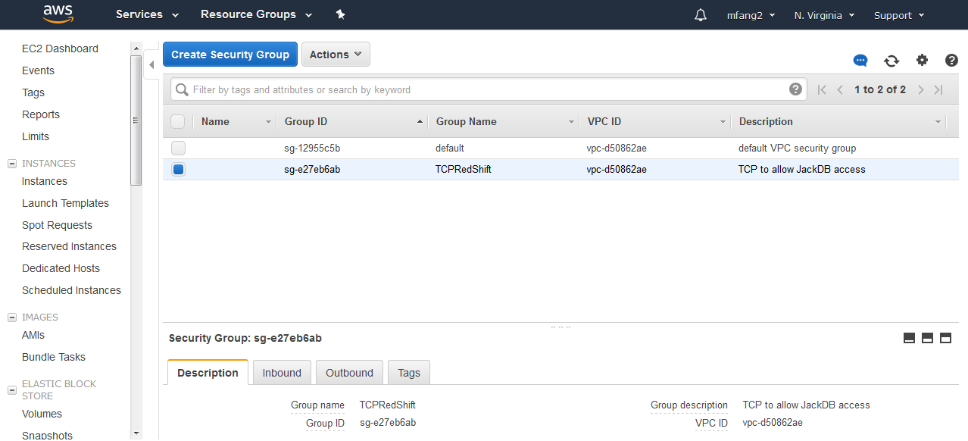

Security group modification failed on windows OS. As it turns out, security groups cannot be added after cluster is launched. Therefore, scrapped and restarted with EC2 VPC security group to allow for incoming TCP.

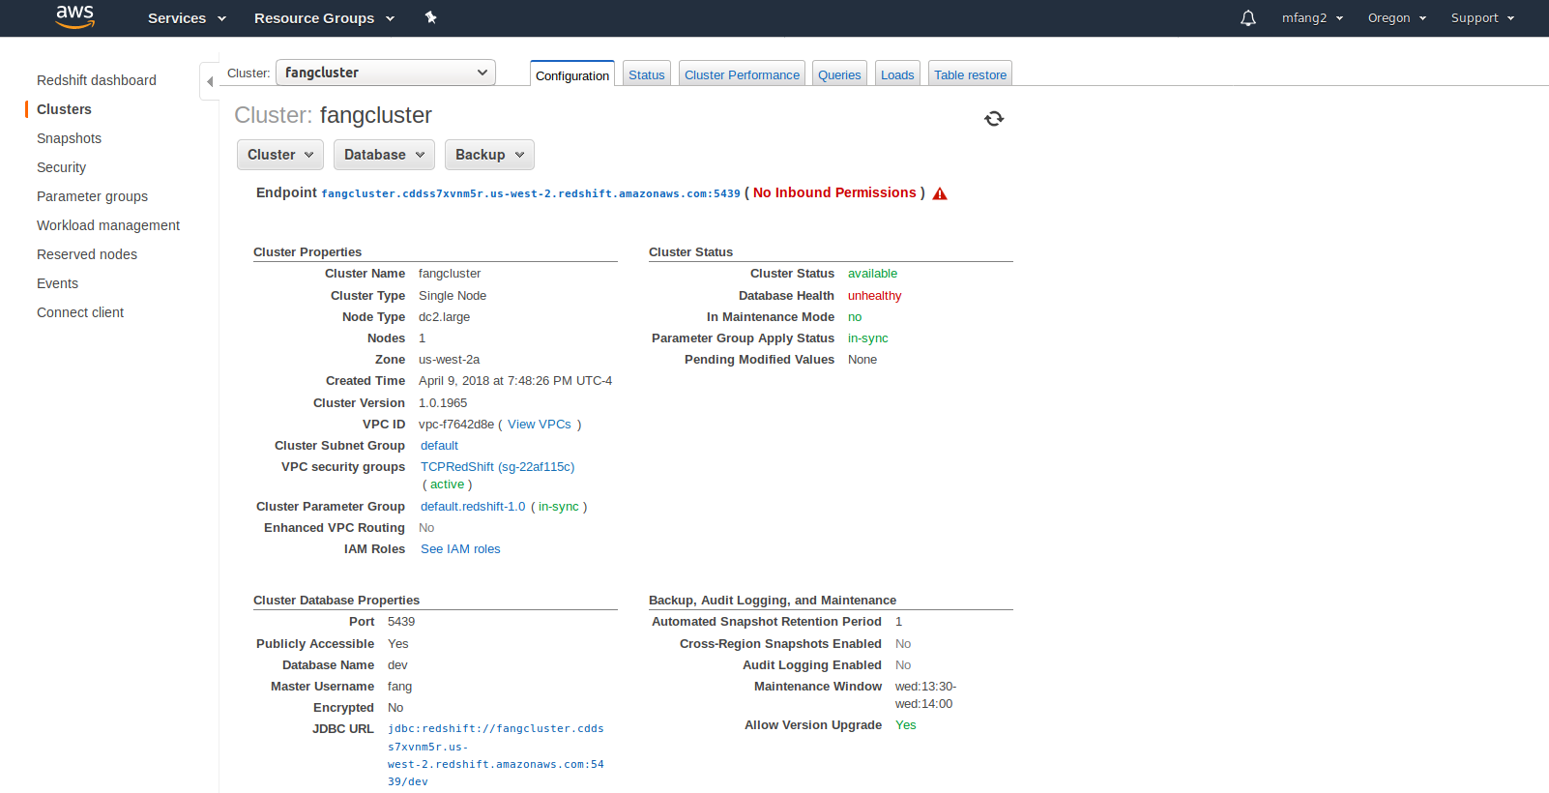

Picture 2 of the cluster
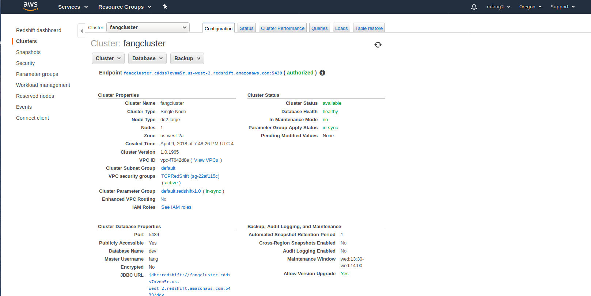

VPC Security Key for it:
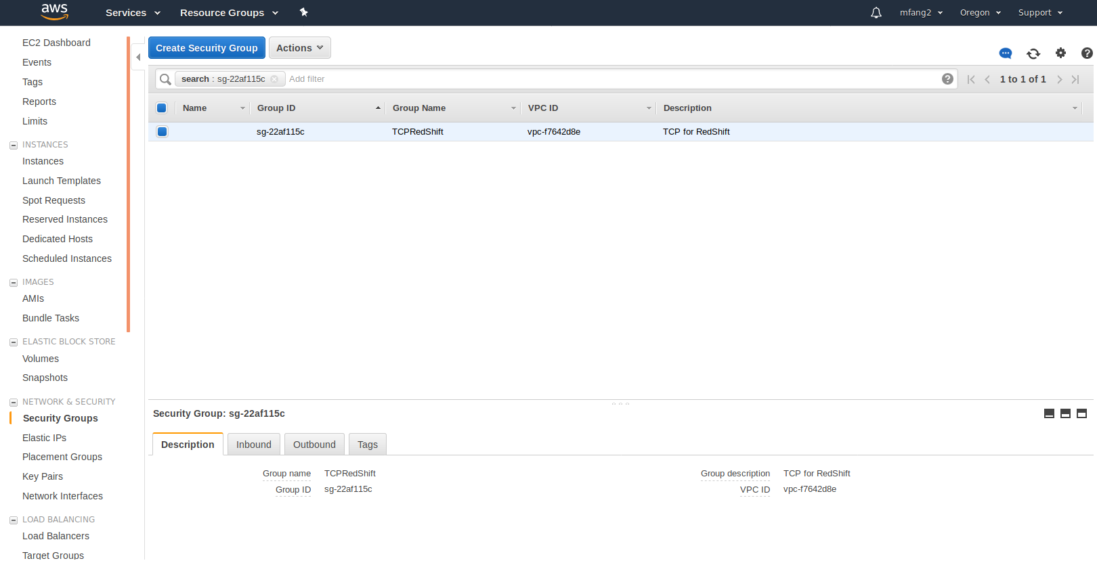

4) Hmm, unable to connect via access key ☹
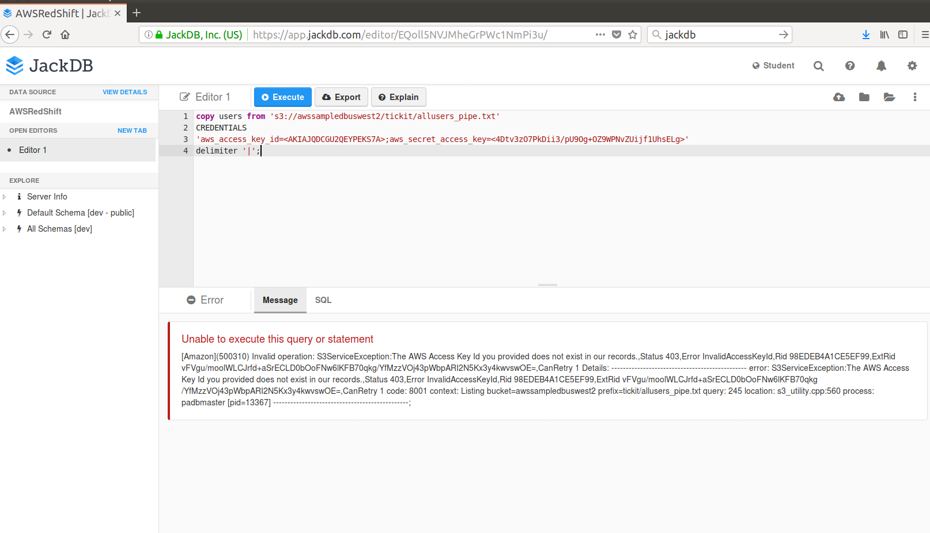

And thus none of the commands work.

